**ĐẠI HỌC BÁCH KHOA HÀ NỘI**

**TRƯỜNG CÔNG NGHỆ THÔNG TIN VÀ TRUYỀN THÔNG**

**----- 🙠🕮🙢 -----**

**THỰC HÀNH LẬP TRÌNH HƯỚNG ĐỐI TƯỢNG LAB 04**

**GVHD: Đàm Quang Tuấn**

**Mã lớp: 744520**

Họ và tên: Phạm Mạnh Quyết

Mã số sinh viên: 20225663

Hà Nội 12/2024

Contents

I. Class diagram 3

II. Use case diagram 4

III. Source code 5

1. Create the Book class 5

2. Creating the abstract Media class 6

3. Creating the CompactDisc 7

3.1. Creating the Disc class extending the Media class 7

3.2. Creating the Track class 8

3.3. Open the CompactDisc class 9

4. Create the Playable interface 9

4.1. Method play() of DigitalVideoDisc class 9

4.2. Method play() of CompactDisc class 10

4.3. Method play() of Track class 10

5. Update the Cart class to work with Media 11

6. Update the Store class to work with Media 12

7. Constructors of whole classes and parent classes 12

8. Unique item in a list 13

9. Polymorphism with toString() method 13

10. Sort media in the cart 15

11. Create a complete console application in the Aims class 16

11.1. Menu chính 16

11.2. Chọn 1: View Store 16

11.2.1. Chọn 1: See a media’s details 17

11.2.2. Chọn 2: Add a media to cart 18

11.2.4. Chọn 4: See current cart 19

11.3. Add media 20

11.4. Remove media 21

10.5. Chọn 3: See current cart 22

10.5.1. Filter medias in cart 22

10.5.2. Sort medias in cart 23

10.5.3. Chọn 5: Place order 25

IV. Question 26

# I. Class diagram

- Source file: 

- Hình ảnh: 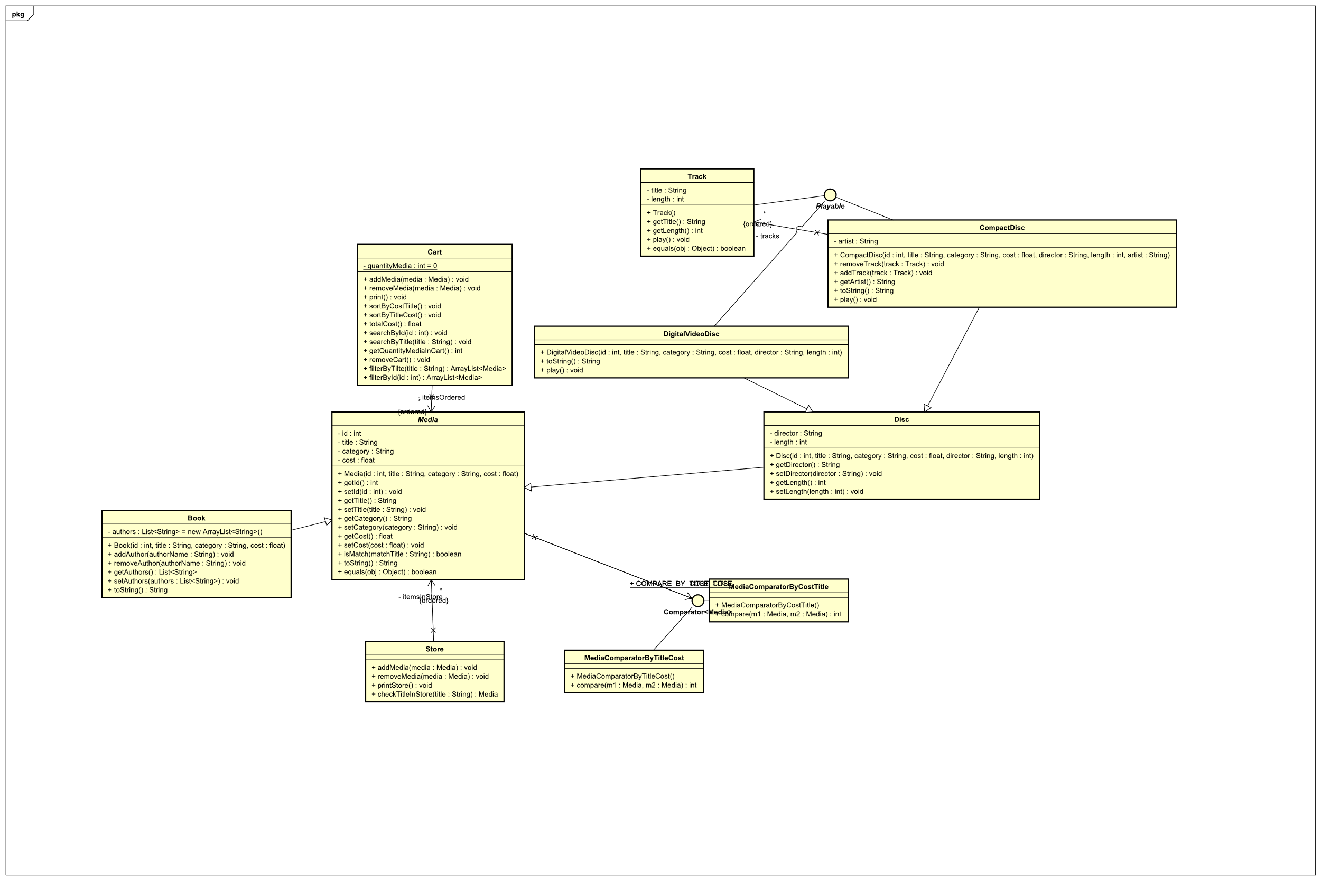

# II. Use case diagram

- Source file: 

# III. Source code

## 1. Create the Book class

## 2. Creating the abstract Media class

## 3. Creating the CompactDisc

### 3.1. Creating the Disc class extending the Media class

### 3.2. Creating the Track class

### 3.3. Open the CompactDisc class

## 4. Create the Playable interface

### 4.1. Method play() of DigitalVideoDisc class

### 4.2. Method play() of CompactDisc class

### 4.3. Method play() of Track class

## 5. Update the Cart class to work with Media

## 6. Update the Store class to work with Media

## 7. Constructors of whole classes and parent classes

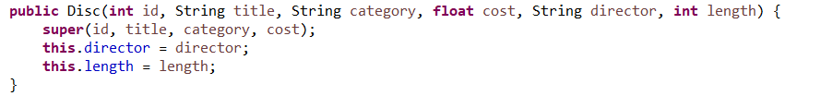



## 8. Unique item in a list

- In Media class

- In Track class

## 9. Polymorphism with toString() method

- Override toString() method in CompactDisc class



- Override toString() method in DigitalVideoDisc class



- Override toString() method in Book class



## 10. Sort media in the cart



## 11. Create a complete console application in the Aims class

### 11.1. Menu chính

### 11.2. Chọn 1: View Store

### 11.2.1. Chọn 1: See a media’s details

### 11.2.2. Chọn 2: Add a media to cart

10.2.3. Chọn 3: Play a media

### 11.2.4. Chọn 4: See current cart

### 11.3. Add media

### 11.4. Remove media

### 10.5. Chọn 3: See current cart

### 10.5.1. Filter medias in cart

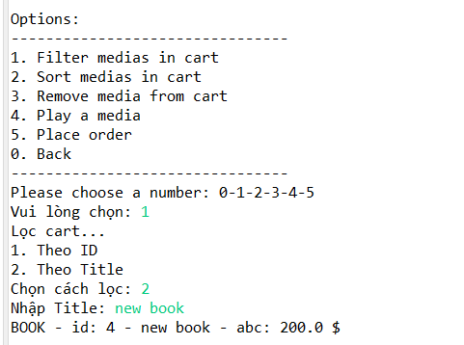

### 10.5.2. Sort medias in cart

- Theo giá rồi tên

- Theo tên rồi giá

### 10.5.3. Chọn 5: Place order

# IV. Question

**1.**Which classes are aggregates of other classes?

TL: Cart, Store là tập hợp (aggregates) của các đối tượng Media, vì nó chứa danh sách các đối tượng Media.

**2.**If the passing object is not an instance of Media, what happens?

TL: Phương thức equals() sẽ trả về false, vì hai đối tượng không thể so sánh được.

**3.** What class should implement the Comparable interface?

TL: Lớp Media: Vì tất cả các loại phương tiện (Book, DVD, CD, v.v.) đều là con của Media, nên quy tắc sắp xếp mặc định nên được định nghĩa trong lớp Media.

**4.**In those classes, how should you implement the compareTo()method be to reflect the ordering that we want?

TL: Trong lớp Media, phương thức compareTo() nên định nghĩa quy tắc sắp xếp mặc định

cho mọi loại phương tiện. Ví dụ: sắp xếp theo tiêu đề trước, rồi đến giá.

**5.** Can we have two ordering rules of the item (by title then cost and by cost then title) if we use this Comparable interface approach?

- Không thể có hai quy tắc sắp xếp với Comparable, giao diện Comparable chỉ hỗ trợ một

quy tắc sắp xếp mặc định được triển khai trong compareTo().

- Nếu cần nhiều quy tắc sắp xếp, phải sử dụng thêm các lớp Comparator.

**6.** Suppose the DVDs has a different ordering rule from the other media types, that is by title, then decreasing length, then cost. How would you modify your code to allow this?

TL: Ghi đè phương thức compareTo() trong lớp con DigitalVideoDisc để áp dụng quy tắc sắp

xếp khác biệt (theo tiêu đề, độ dài giảm dần, rồi đến giá).